Coding Related Stuff

1. For each loop never gives the index , it gives the value of that index.
2. Frequency of Character in a string …

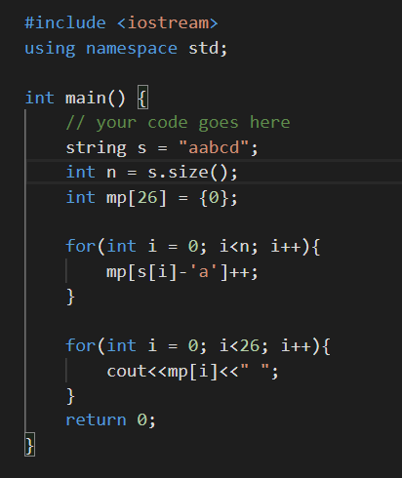

Sliding Window Technique

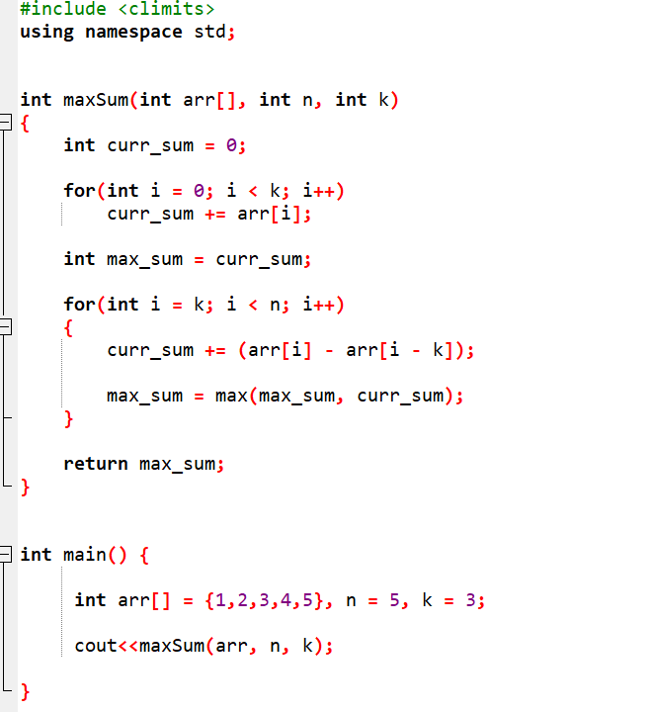

Factorial of N number(No. of ways to rearrange or place n thing)

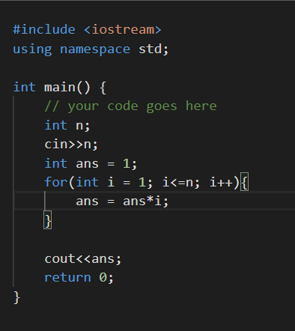

In this way we can insert Two array into one vector of pair

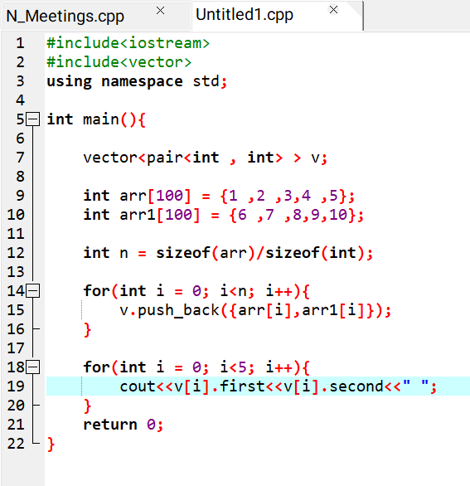

Character and Frequency in Map

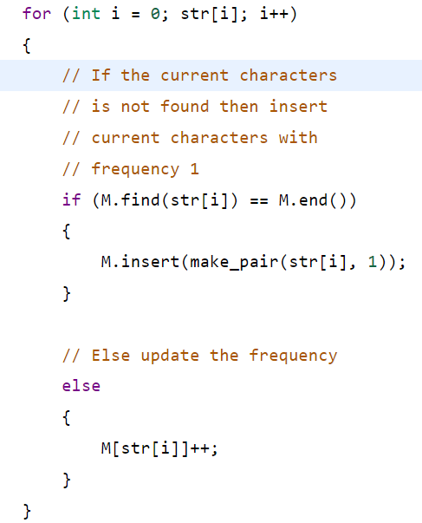

To find right minimum or right maximum or left minimum or left maximum

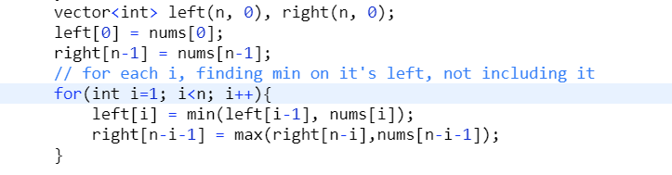

As we know inbuilt sort function sort the array in increasing order , but if you want to sort it in decreasing order then we have to pass greater<int>() to our sort function .